Exercise 1: Configuring a Basic Spring Application
Scenario:
Your company is developing a web application for managing a library. You need to use the Spring Framework to handle the backend operations.
Steps:
- Set Up a Spring Project:
  - Create a Maven project named LibraryManagement.
  - Add Spring Core dependencies in the pom.xml file.
- Configure the Application Context:
  - Create an XML configuration file named applicationContext.xml in the src/main/resources directory.
  - Define beans for BookService and BookRepository in the XML file.
- Define Service and Repository Classes:
  - Create a package com.library.service and add a class BookService.
  - Create a package com.library.repository and add a class BookRepository.
- Run the Application:
  - Create a main class to load the Spring context and test the configuration.

OUTPUT:
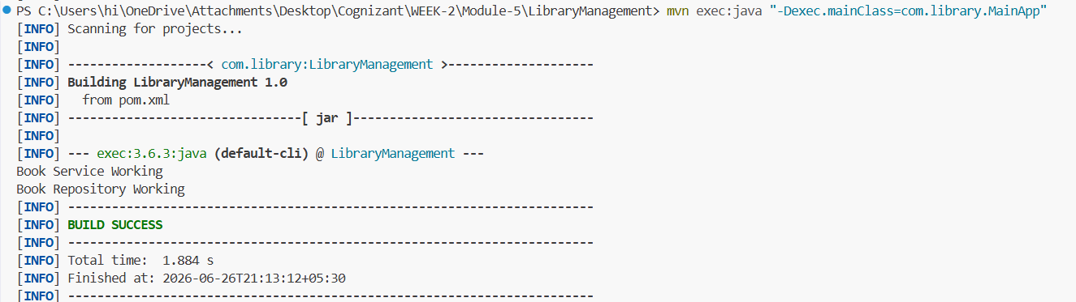

Exercise 2: Implementing Dependency Injection
Scenario:
In the library management application, you need to manage the dependencies between the BookService and BookRepository classes using Spring's IoC and DI.
Steps:
- Modify the XML Configuration:
  - Update applicationContext.xml to wire BookRepository into BookService.
- Update the BookService Class:
  - Ensure that BookService class has a setter method for BookRepository.
- Test the Configuration:
  - Run the LibraryManagementApplication main class to verify the dependency injection.

OUTPUT:
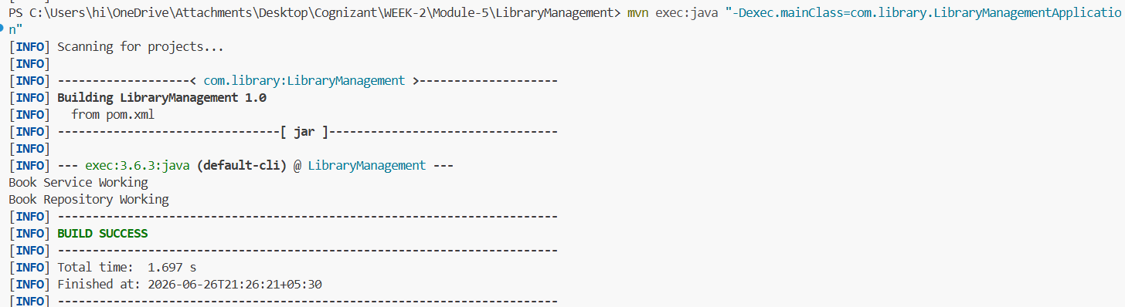

Exercise 3: Implementing Logging with Spring AOP
Scenario:
The library management application requires logging capabilities to track method execution times.
Steps:
- Add Spring AOP Dependency:
  - Update pom.xml to include Spring AOP dependency.
- Create an Aspect for Logging:
  - Create a package com.library.aspect and add a class LoggingAspect with a method to log execution times.
- Enable AspectJ Support:
  - Update applicationContext.xml to enable AspectJ support and register the aspect.
- Test the Aspect:
  - Run the LibraryManagementApplication main class and observe the console for log messages indicating method execution times.
OUTPUT:
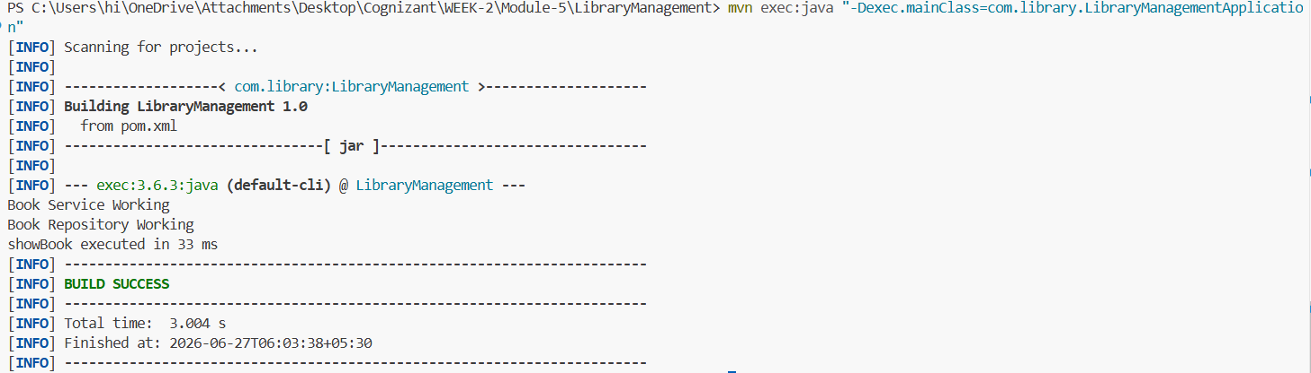

Exercise 4: Creating and Configuring a Maven Project
Scenario:
You need to set up a new Maven project for the library management application and add Spring dependencies.
Steps:
- Create a New Maven Project:
  - Create a new Maven project named LibraryManagement.
- Add Spring Dependencies in pom.xml:
  - Include dependencies for Spring Context, Spring AOP, and Spring WebMVC.
- Configure Maven Plugins:
  - Configure the Maven Compiler Plugin for Java version 1.8 in the pom.xml file.
OUTPUTS:
1.Structure of the new maven project file.
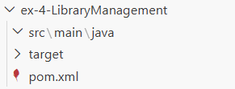

2. Dependencies for Spring Context, Spring AOP, and Spring WebMVC.
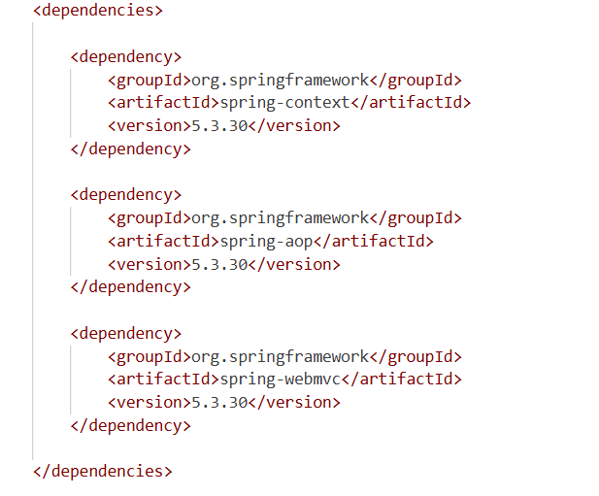
3. Configured the Maven Compiler Plugin for Java version 1.8 in the pom.xml file.
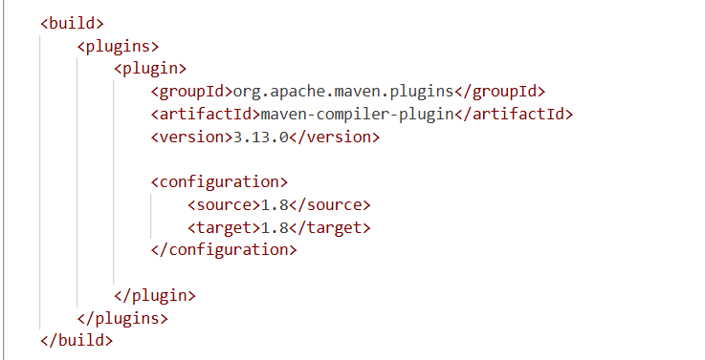
4.run output of the project.
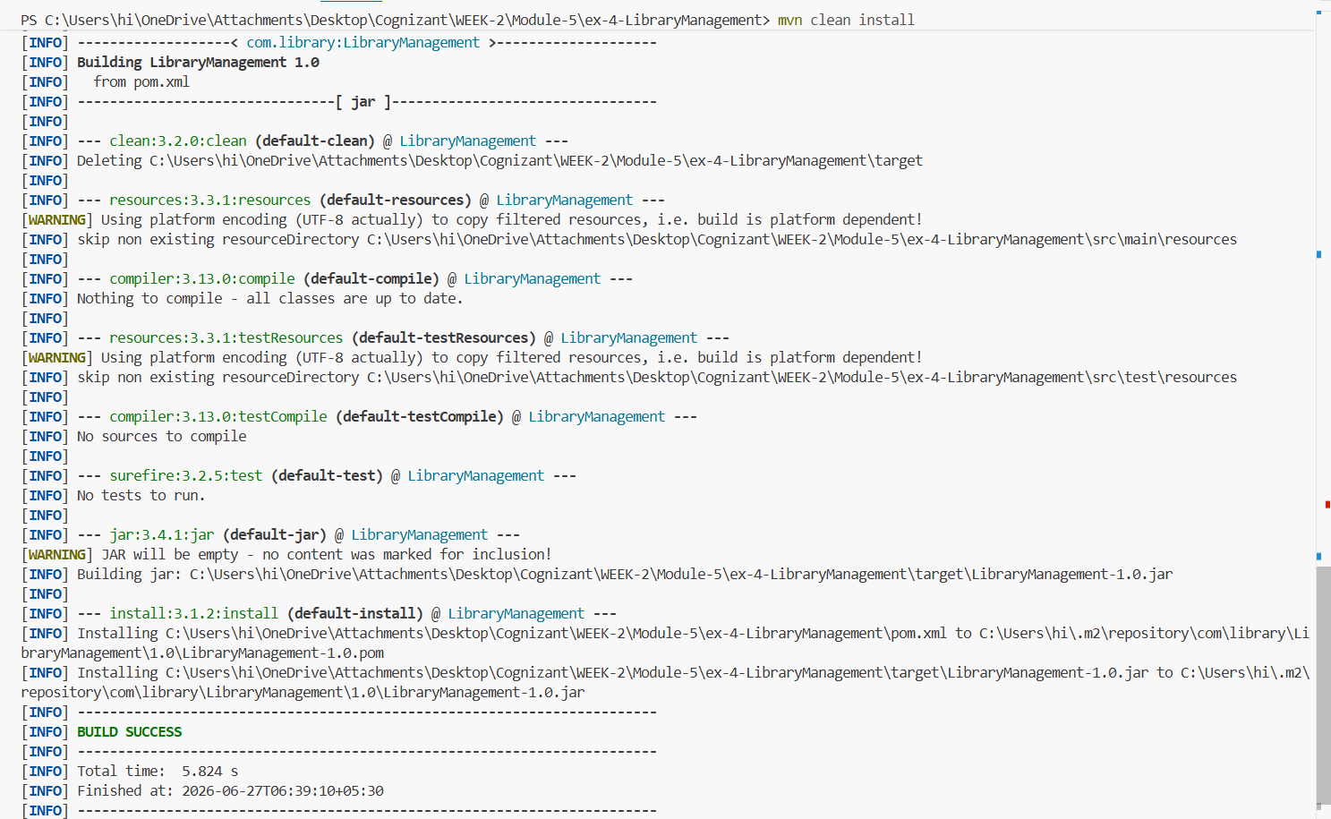
Exercise 5: Configuring the Spring IoC Container
Scenario:
The library management application requires a central configuration for beans and dependencies.
Steps:
- Create Spring Configuration File:
  - Create an XML configuration file named applicationContext.xml in the src/main/resources directory.
  - Define beans for BookService and BookRepository in the XML file.
- Update the BookService Class:
  - Ensure that the BookService class has a setter method for BookRepository.
- Run the Application:
  - Create a main class to load the Spring context and test the configuration.
OUTPUTS:
1.defined beans for BookService and BookRepository in the XML file.
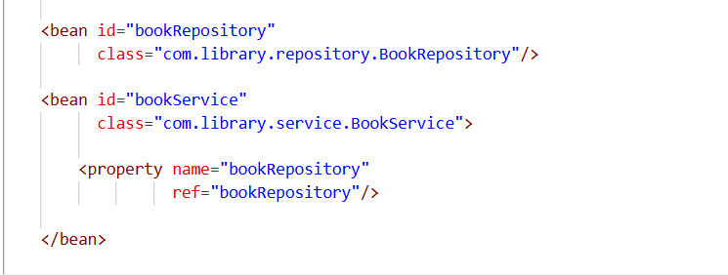
2. the BookService class has a setter method for BookRepository.
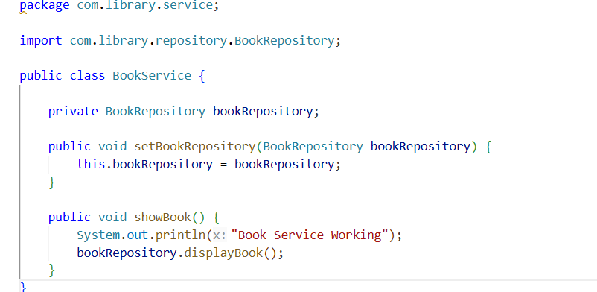

3.run output of the project file.
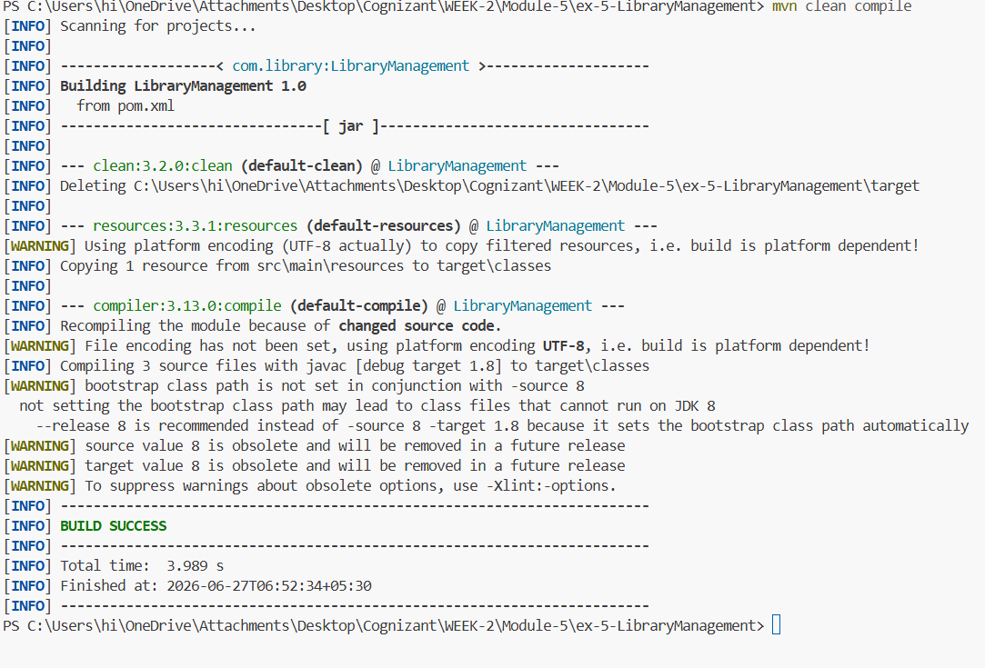

Exercise 6: Configuring Beans with Annotations
Scenario:
You need to simplify the configuration of beans in the library management application using annotations.
Steps:
- Enable Component Scanning:
  - Update applicationContext.xml to include component scanning for the com.library package.
- Annotate Classes:
  - Use @Service annotation for the BookService class.
  - Use @Repository annotation for the BookRepository class.
- Test the Configuration:
  - Run the LibraryManagementApplication main class to verify the annotation-based configuration.

Exercise 7: Implementing Constructor and Setter Injection
Scenario:
The library management application requires both constructor and setter injection for better control over bean initialization.
Steps:
- Configure Constructor Injection:
  - Update applicationContext.xml to configure constructor injection for BookService.
- Configure Setter Injection:
  - Ensure that the BookService class has a setter method for BookRepository and configure it in applicationContext.xml.
- Test the Injection:
  - Run the LibraryManagementApplication main class to verify both constructor and setter injection.
Exercise 8: Implementing Basic AOP with Spring
Scenario:
The library management application requires basic AOP functionality to separate cross-cutting concerns like logging and transaction management.
Steps:
- Define an Aspect:
  - Create a package com.library.aspect and add a class LoggingAspect.
- Create Advice Methods:
  - Define advice methods in LoggingAspect for logging before and after method execution.
- Configure the Aspect:
  - Update applicationContext.xml to register the aspect and enable AspectJ auto-proxying.
- Test the Aspect:
  - Run the LibraryManagementApplication main class to verify the AOP functionality.

Exercise 9: Creating a Spring Boot Application
Scenario:
You need to create a Spring Boot application for the library management system to simplify configuration and deployment.
Steps:
- Create a Spring Boot Project:
  - Use Spring Initializr to create a new Spring Boot project named LibraryManagement.
- Add Dependencies:
  - Include dependencies for Spring Web, Spring Data JPA, and H2 Database.
- Create Application Properties:
  - Configure database connection properties in application.properties.
- Define Entities and Repositories:
  - Create Book entity and BookRepository interface.
- Create a REST Controller:
  - Create a BookController class to handle CRUD operations.
- Run the Application:
  - Run the Spring Boot application and test the REST endpoints.

